TOTAL HERD MANAGEMENT SERVICES, INC.
ANDREW P. JOHNSON, DVM
W 8275 CLOVERLEAF LAKE ROAD
CLINTONVILLE, WISCONSIN 54929
drandy@theudderdoctor.com

FREE STALL GUIDELINES (Version 9/08)

COW COMFORT IS THE MOST IMPORTANT ELEMENT IN EFFICIENT PRODUCTION AND PROFITABILITY. IF A COW IS COMFORTABLE, SHE WILL MAXIMIZE HER PERFORMANCE. STALL DESIGN IS CRITICAL TO COW COMFORT AND HEALTH. BE CERTAIN NEW FACILITY EMPLOYS MANAGEMENT PRACTICES THAT REDUCE PATHOGEN LOAD AND INCREASES THE COW’S ABILITY TO FIGHT DISEASES.

A. STALL SIZE (All stalls are not created equal)
The ideal stall width is 46 inches. The range is 46 to 48 inches. Stalls wider than 48 inches is not recommended because cows are dirtier in a wider stall and more manure ends up in the stall. The ideal stall length is 7.5 to 9 feet depending on location. If building head to head stalls, I would recommend 16 to 17 feet from curb to curb to protect cows from summer heat. If stalls are on outside wall, the bed should be 8.5 to 9 feet long unless you install off set curtain, then the stall would be 7.5 feet long. Remember, it costs no more to do it right the first time! KEY POINT: I am talking inside barn dimensions, builders talk outside barn dimensions. If the wall width is forgotten, your stalls will not fit!

B. STALL LOOP (Loops, even when they look the same, they can be wrong)
The stall loop used is critical to cow comfort. The cow must have the choice to properly lunge forward or to either side. Video study showed 67% of all animals lunged to side if the option was present. It is important that you don’t decide what the cow can do but instead allow her to make her own decisions. A properly designed loop can meet the cow’s needs. Remember, many loops look right but are old versions that are obsolete. The loop is the key factor to both milk production and cull rates. Here are some suggestions on how to pick the proper loop. (See figure 1 and 2)

1. The distance from the bedding to the top of the lower bar of the free stall loop should be 9-10 inches. The vast majority of loops are mounted so the lower bar is too high causing side way lunge problems. The cows usually choke themselves when lunging sideways.

2. The bottom bar of the free stall loop should be 42 to 60 inches long before it bends depending on stall length. (See figures 1+2) This helps position the cow to lay straighter in the stalls and keep her from injuring their hip when lunging forward.

3. The distance from the bedding to the top of the loop should be a minimum of 46 inches with a maximum height of 48 inches. The neck rail should be mounted to the top of the loop 60 to 65 inches in from the back of the curb. In start up dairies where cows have not used free stalls before, I would suggest putting the neck rails at 66-68 inches initially then in 3-6 weeks move them back to 60-65 inches. The two biggest problems are too low of neck rail and neck rails too far forward. Both of these cause discomfort and dirtier cows. Many cows hit the neck rail when getting up creating some discomfort.

4. The loop that provides maximum comfort has an outside span of 39 inches. The inside space will vary depending on the tube size of steel used. Narrower loops will compromise cow comfort. There are many farms that have 36 inch in one barn and 39 inch in the other and can see a difference. The 39 inch loop definitely promotes cow comfort.

5. It is critical that the loop is specifically designed for the stall bed length. The end of the loop should be 8 inches from the back of the curb. The maximum distance is 12 inches. If the loops are too short, the stalls will be dirtier. (See figure 1+2)

6. The best way to mount loops is on vertical 6X6 posts. This provides the most open space for the cow. If the stalls are to be mounted on horizontal mounts, be sure the horizontal mounts do not limit the cows lunge. The top horizontal barn must be flush at the bottom of the top loop and flush with the top of the bottom loop. (See figure 3)

C. THE STALL BED
There are many options for the stall bed. Sand is the best option, after that, you choose your own poison. The second best option is well bedded multi-cell mattresses with extra 2 inches of foam padding.. Rubber mats are not considered a good option. Tires, if installed properly, can be used to decrease sand use in the stalls. The tires must be hand packed and be a minimum of 3 inches below the lowest point of the curb. Sandtraps are also available to limit sand use. The value of sand is over $500/cow per year over mattresses.

1. Every free stall should have a brisket board. The brisket board helps position the cow properly in the stall and assists the cow to get up with less effort. I think the brisket board is one of the most important parts of a free stall. To properly install a brisket board, the distance from the back of the curb to the center of the brisket board is 66-68 inches. There is absolutely no reason to make it longer and in fact, usually makes things worse. I would recommend a 2X8 or 2X10 for the brisket board. Approximately 45% of the board should be above the bedding line and 55% below. The most common mistake is mounting the brisket boards too high. The board should be at a 50-60 degree angle. (See figure 5B)

2. Every stall should have 2 inches of slope from the curb to the front of the stall. Cows prefer laying slightly uphill. Do not exceed 3 inches of slope!

3. The rear curb should never be higher than 10 inches. Cow do not like stepping up higher distances. If sand is used, pour the outside curb 10 inches (2X10) and the inside 8 inches (2X8). This prevents a sharp edge to damage the udder as sand levels drop. If using mattress, then make a square 8 inch (2X8) curb so the final height will be 10 inches including the mattress width. (See figures 4+5)

D. FREE STALL BARN DESIGN OPTIONS: (See figure 8,9,10)
Quality free stall barns can be designed as 3 row, 4 row, 5 row, or 6 row. Most are designed with drive through or drive by feed alleys. When building a 4 row barn, I prefer tail to tail design rather than head to head. Tail to tail has more comfort especially in hot weather, allows for better cow performance and handling, forces all animals to walk past water, and gives more stalls in the barn. Before you build, look at a minimum of 10 new barns. Look at ones your builder wants you to see plus others.

Two key questions to ask when visiting the farms is milk production level and cull rate. If all the barns the builder have done have low production, you should be concerned. The more information you have, the better your new barn will be. Cost of new barns can range from $2,400 to $2,800 per stall.

Another option to consider is to widen the alleys. In everyone’s attempt to reduce cost, there is too many cows per square inch in the barns and the animals get very dirty even with constant scraping. Instead of 10 feet cow alleys, go with 12 feet. Instead of 12 feet feed alley, go with 15 feet. The wider alleys definitely result in cleaner cows.

A great investment for cow comfort is the installation of rubber belts in the alleys. Put a 12 inch belt immediately behind the feed manger curb. Go back 30 inches and put a 36 inch belt in the alley. This way the front and rear feet are on rubber while the cow eats and there is a padded walk way for cows to walk behind the cows that are eating. A 24 inch strip of rubber is placed in the center of the cow alley. Many people also put 24 inch strips of rubber in walk ways to the parlor too. Holding areas can be padded as can the cow decks in the parlors. The cost for rubber is approximately $3 a square foot.

E. VENTILATION (NATURAL OF COURSE)
Ventilation is a key factor in cow performance and health. Natural ventilation is the best option when trying to maximize cow comfort and health. The roof pitch must be 4:12. All research is clear there is a distinct advantage with a 4:12 pitch over less pitch. There are many arguments for insulating the roofs. About 75% of the barns I work with do not insulate and get high milk production. Insulation is best for summer. The side walls should be 14 to 16 feet high. The over hang should be at least 4-5 feet. The curtains should always roll up from the ground. If split curtains are used, the lower one rolls down and the upper one rolls down and they are stored in the middle of the side wall. On some systems, once the curtains are fully opened, they can be raised and stored under the over hang which is really nice.
A new feature is the off set curtain design which adds to cow comfort and protects the curtain. (Figure 11) The roof ridge should not be covered and should be 3 inches wide per 10 feet of building width or 12 inches wide for the first 20 feet of building width plus 2 inches per additional 10 feet of building width. The side eaves should be 1 inch per 10 feet of building width. I prefer closing the eaves under the rafters and have the curtain be the opening. This way, under extremely bad weather conditions, you have more control of the environment.

Many farms are installing large fans, but for maximum effect, they should be mounted over the cow beds. You need 1000 CFM per cow to cool cows. When using 36 inch fans, mount every 20 feet. When using 48 inch fans, mount every 40 feet. Fans should be installed 7.5-8 feet above the cow beds with a 15-25% downward tilt. Fans should come on when air temperature exceeds 68 degrees F especially at night during the summer. Sprinkler systems can also be useful in the holding area, the feed alleys and the return lanes to reduce the stress of hot weather. (See figure 11)

F. MANGERS
Manger space is critical to cow performance. Cows like to eat fresh feed and be comfortable while eating. Dry matter intake is a key to higher production. There is very little feed value in cement. You need 16-24 inches of bunk space per cow. Cables, pipes, or self locks can be used on mangers. Here are some important manger tips: (Figure 6)

1. The feed manger should be 4 to 6 inches higher than the feet of the cow. The surface must be smooth and easy to clean.

2. Drive through feed alleys should be 18-20 feet wide.

3. Use a two inch pipe or coated cable for feeding neck rail. Mount pipe or cable on the feed side of the post and make sure it is extended over the feed 2 inches beyond the curb edge. Too many neck rails limit intakes and cause bruising on the cow’s necks.

4. If self locks are used, I prefer them to be tilted 10-15% towards the feed.

5. The pipe or cable should be mounted 46 inches off the floor where the cow’s stand.

6. The manger curb is usually 6-8 inches wide and 20 to 24 inches high on the side the cow stands. Higher curbs allow for once a day feeding.

G. WATER SUPPLY
Adequate water supply is critical to maximize production. Water is the cheapest source of nutrition on the farm. Every new facility must install water meters so you can monitor water intakes. You need 2-2.5 inches of water trough space per cow with a minimum pressure of 6 gallons.

There needs to be enough waterers to provide adequate water to the cows especially in the summer months. The minimal width of alley by waterer should be 14-16 feet. I like trough waterers best. The longer the better.

A water meter must be installed on each water line supplying each pen of cows. Knowing water intake can resolve many milk production problems. The water meter may be your best investment in your new facility!!

Limited water supply is a problem on many farms. Having a large tank at the end of the return area with plate cooler water is great. Cows will drink the most water immediately after milking if available. When putting water space in the return lanes, you need 2-2.5 feet of water space per parlor milking stall. I would avoid ball type waterers because they limit water intake and get extremely dirty inside. Trough waterers are easier to manage.

H. LIGHTING (Minimum 20 foot candles)
Use of long life sodium or mercury lights. These are economical to use. Good lighting is important to reproduction performance as well. It is a good idea to set lights up on timers in case you want to control the amount of light in the barn. Barns need to have light placed equally over the entire barn so there are at least 20 foot candles of light for 16 to 18 hours a day. Every barn should have 6 to 8 hours of darkness. (Less than 4 foot candles). A simple rule of thumb is to have enough light so you can read a newspaper laying on the manger of the barn.

I. FOOTBATHS
Be sure to install footbaths on your dairy. I would suggest always installing two foot baths on each return lane. The first will have plain water and the second will have the medication. The footbaths must be designed so they can be cleaned and filled easily. Automatic fill foot baths are a great investment for any dairy farm. The foot baths can be poured in the return lanes and should be as far from the parlor as possible so cow flow is not adversely affected.

J. PALPATION OR MANAGEMENT RAIL
This is a low cost holding facility for handling cows on herd health, treatments, or for reproductive work. This can be done with little expense and can be incorporated in the return lanes. It is very important to design the palpation rails so there is no vertical pipe between the top and bottom rail. This allows cows to exit easier and faster. The addition of hog panels on the lower part of the rail is useful and helps cows load faster. (See figure 7)

K. HOLDING AREA
The approximate space needed per cow for the holding area is 15 square feet plus 25% so there is room for the next group to enter the holding area. The perfect holding area will be sized so each group of cows can be milked in one hour or less. The holding area should have 2-4% slope going up to the parlor. Too much slope can lead to problems.
Holding areas must be properly ventilated and should have fans. You need 1000 CFM per cow in the holding area. Fans best put in banks blowing away from parlor. A sprinkler system should also be installed. An insulated roof should be considered for holding areas. Consider double return lanes for the holding area.

If you are going to design a new free stall barn or remodel an older barn, the cows should response in a positive manner immediately. Cows do not have to “get use” to a properly designed barn. If the animals are not using the stalls, something is wrong with cow comfort. Before you make a final decision on who will build your barn, have them show you all the barns they have done with 85 pound or higher milk averages. If they have none, you might start to worry. Look at as many barns as you can. Utilize an independent consultant to help you make decisions. This person will have nothing to sell and their main goal is to help you sort through the information and make proper decisions. Builders are excellent at pounding nails and welding, however, few truly understand cow comfort. If your new barn is almost right, it will only cost you milk production for every day of the year forever. It DOES NOT cost any more to build your new free stall right than almost right! My best advice, plan, plan, and plan some more.

Figure 3: Horizontal Mounting Figure 4: Curb Design - Sand

Top Mounting Bar
10” 8”

Note: Flush mounting of loops!

Lower Mounting Bar
Figure 5: Curb Design - Mattress

8” 8”

Figure 5B: Proper Brisket Board Location

Level Line From Top of Curb
45%
55%

Figure 1: Loop for Sand Stalls:
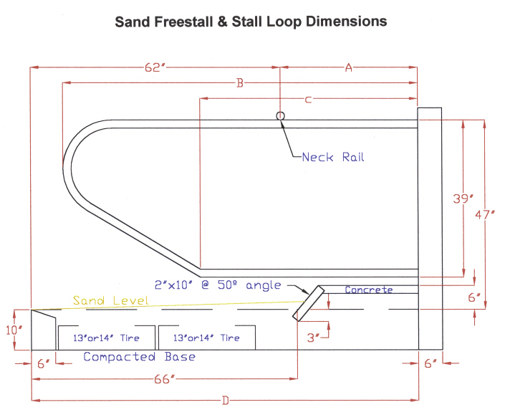
Key
Measurement
9 inches

FREESTALL LENGTH DIMENSIONS

Stall Bed inches
Length
A B C D

7.0 ft 22 76 42 84

7.5 ft 28 82 48 90

8.0 ft 34 88 54 96

8.5 ft 40 94 60 102

Figure 2: Loop for Mattress Stall:
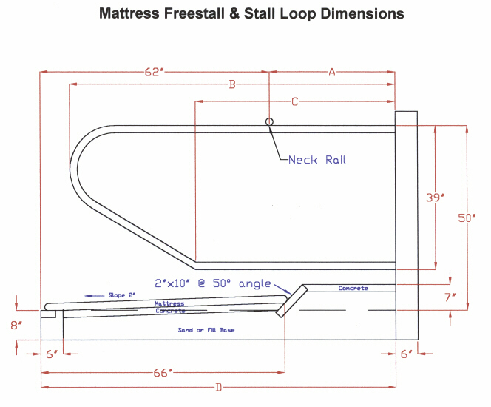
KEY
MEASUREMENT
9 inches

FREESTALL LENGTH DIMENSIONS

Stall Bed inches
Length
A B C D

7.0 ft 22 76 42 84

7.5 ft 28 82 48 90

8.0 ft 34 88 54 96

8.5 ft 40 94 60 102

Figure 6: Proper Manger Design
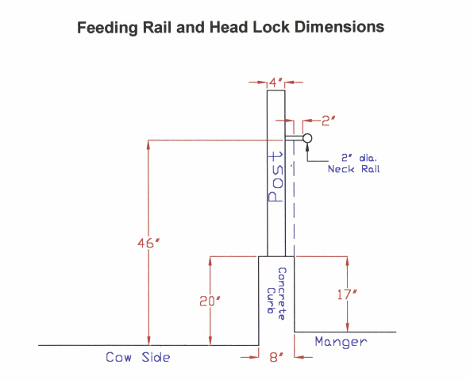

Figure 7: Palpation or Management Rail

PALPATION OR MANAGEMENT RAIL

Front Rail (Use 3 to 4 inch steel pipes)
If you can avoid vertical support posts between top and bottom pipe, cow exit will be much easier as well as faster.

KEEP THIS SPACE OPEN!!
58-60 inches

30-36 INCHES inches
6 inches
Optional Hog Panel

Rear Rail:

40 inches
6 inches
Optional lower rail
20 inches off floor
Optional Hog Panel

Top view of both palpation rails:

4 feet
4 feet

4 feet

Each rail is 40 feet long. The rails are off set by four feet. Take a six foot gate and
cut to length of 5 feet 6 inches to fit across the off set opening.

ADDITIONAL NOTE: You may want to make the floor where the people stand 4 inches higher than where the cows stand. This will make it easier to palpate and hold manure.

Further Information: Dr. DK Hardin, U of Missouri, College of Agriculture
Dr. Julie Larson, Sun Ray Dairy, 608-857-3619
Monsanto Dairy, 800-233-2999

Figure 8: Three Row Design

BEST THREE ROW BARN PLAN
OUTSIDE FEEDING

Outside Row 45 inches wide
Best 8.5 feet long 8 feet ok

Outside Row 45 inches wide
Best 8.5-9 feet long 8 feet ok

10-12 foot cow alley

Head to Head Stalls
45” wide 7.5 ft long
46-4
feet
wide
Head to Head Stalls
45” wide 8.0 ft long*
46-53
feet
wide

10-12 ft

10-12 ft

12 ft

12 ft

*Consider 8.5 ft if in hot areas!

Head to Head Stalls
45” wide 7.5 ft long
Head to Head Stalls
45’’ wide 8.0 ft long*

12-14 foot feed alley
12-15 foot feed alley

3-4 foot feed pad
4 foot feed pad

BEST THREE ROW BARN PLAN
INSIDE FEEDING

Outside Row 45 inches wide
Best 8.5 feet long 8 feet ok

Head to Head Stalls
45” wide 7.5 ft long
Head to Head Stalls
45” wide 7.5 ft long
10 foot cow alley
12-14 foot feed alley
3-4 foot feed pad

46-48
feet
wude
10-12 ft

10-12 ft
Outside Row 45 inches wide
Best 8.5-9 feet long 8 feet ok

Head to Head Stalls
45” wide 8.0 ft long*
Head to Head Stalls
45” wide 8.0 ft long*
10-12 foot cow alley
12-15 foot feed alley

12 ft

12 ft
14-16 FOOT DRIVE THROUGH FEEDING
*Consider 8.5 ft
if in hot areas!

60-69
feet
wide

Figure 9: Four Row Design

FOUR ROW FREE STALL BARN
Outside Row 45 inches wide
Best 8.5-9 ft long 8 ft Ok
Inside Row 45 inches wide
7.5 ft long

12 ft

12 ft

10-12 foot alley

12 - 15 foot alley
Inside row 45 inches wide
7.5 ft long
12-15 foot alley

12 ft
Outside row 45 inches wide
Best 8.5-9.0 ft Ok 8.0 ft
10-12 foot alley

94
to
105
feet
wide

18-20 foot drive through feeding

12 ft

Figure 10: Six Row Design

SIX ROW FREE STALL BARN

Outside Row 45 inches wide
Best 8.5 feet long 8 feet ok

Head to Head Stalls
45” wide 7.5 ft long
Head to Head Stalls
45” wide 7.5 ft long
10 foot cow alley
12-14 foot feed alley
3-4 foot feed pad

46-48
feet
wude
10-12 ft

10-12 ft
Outside Row 45 inches wide
Best 8.5-9 feet long 8 feet ok

Head to Head Stalls
45” wide 8.0 ft long*
Head to Head Stalls
45” wide 8.0 ft long*
10-12 foot cow alley
12-15 foot feed alley

12 ft

12 ft
18-20 FOOT DRIVE THROUGH FEEDING
Outside Row 45 inches wide
Best 8.5 feet long 8 feet ok

Head to Head Stalls
45” wide 7.5 ft long
Head to Head Stalls
45” wide 7.5 ft long
10 foot cow alley
12-14 foot feed alley

10-12 ft

10-12 ft
Outside Row 45 inches wide
Best 8.5-9 feet long 8 feet ok

Head to Head Stalls
45” wide 8.0 ft long*
Head to Head Stalls
45” wide 8.0 ft long*
10-12 foot cow alley
12-15 foot feed alley

12 ft

12 ft
*Consider 8.5 ft
if in hot areas!

*Consider 8.5 ft if in hot areas!

110-124
feet
wide

Figure 11: Off Set Curtain Design

OFF SET CURTAIN DESIGN

The new off set curtain allows for more cow comfort plus it protects the curtain. This new design should not add much additional cost to the building. The farms that have implemented this design are extremely pleased with the results. The off set curtain should be used in all free stall barns that have cows on the outside wall. The off set curtains allows you to use a 7.5 foot stall rather than the 8.5 to 9 foot stall and you do not have to buy the hog fencing to protect the curtains. The off set curtain allows your to build a narrower building which also saves you money. The extra expense is a few extra posts to mount the loops. This is an excellent investment for hot weather conditions too.

3 feet
2 feet
Free air space and walking area
Curtain mounts on
this wall
Bedding Level
7.5 foot stall bed
3 feet

HEIFER FACILITY RECOMMENDATIONS:
Replacement Heifer Freestall Dimensions

Age Weight Freestall Bed Size Bed Size Distance from rear Months pounds width/in Length/in length/in curb to Brisket board

Head to Head Stalls attached
shared lunge to solid wall

4-6 275-400 30 60 66 46
7-9 450-575 32 60 66 46
10-12 650-775 36 65 71 49
13-15 825-925 38 75 81 57
16-18 975-1050 40 85 91 62
19-21 1125-1225 42 90 96 62
22-24 1275-1350 44 90 96 65

> Heifers under 6 months of age should not be housed in freestalls. A bedded
pack of 28 sq ft/animal is recommended for heifers 0-5 months. Heifers from 3-
4 months should be housed in small groups (5-10) to reduce competition.
> Neck rails should be mounted directly above to one inch behind brisket board.

Suggested dimensions for post and rail feeding mangers

Age, months Weight, lbs. Throat height, inches Neck rail height, inches

>6-8 350-550 14 28
9-12 550-750 16 30
13-15 825-925 17 34
16-24 975-1350 19 41

> A diagonal bar feeding fence is recommended for this group to prevent calves
from escaping. Leave 7 inch spaces between adjacent bars for calves.
> If lockups are installed, contact manufacturer for throat height recommendations
> Feeding rail and the top of lockups should be positioned 4-6 inches forward of
the rear of the manger curb.

Feed space requirements

Age in months
Type 3-4 5-8 9-12 13-15 16-24 Mature Cows
TMR Space: Inches per animal
Continuos fed 10 6 12 14 16 18
Once a day feeding 12 15 18 20 22 24

